

Compiled by Lucinda Flynn

Double glazing – is it the best way to improve your windows?

Almost everyone is aware of double glazing and that it can improve the thermal efficiency – or the ability to slow down heat transfer – of your windows. This is because it is so highly marketed.
However, what many people do not realise, is that there are several factors that impact on the thermal efficiency of your windows. Installing double glazed windows is just one of many options that you can choose from to improve the thermal efficiency of your windows.
This is good news for householders, since replacing window units with double glazed ones is very expensive. Read on to learn more about how windows transfer heat, and to learn about a range of ways you can improve yours, some of which can cost you almost nothing.

Here are the factors that impact the thermal efficiency of windows:
- Internal window coverings and pelmets
- External shading
- Making the most of what you have
- Glazing (glass)
- Frames

Internal window coverings and pelmets

Window coverings
Because they are not as highly marketed, many people are unaware of the significant improvement you can make to your windows with good window coverings without the need to upgrade windows. Likewise, many people think that pelmets are ornamental rather than an effective way to reduce heat transfer.
The chart below shows that a single glazed window with a heavy, lined curtain with a pelmet (blue arrow) is actually BETTER at reducing heat transfer, than a double-glazed window with no internal window covering (orange arrow). You can also see that simply adding a pelmet to unlined curtains or a holland blind (blue star), reduces heat transfer compared to the same window covering with no pelmet (orange star). Where double glazing is not specified, the window is single glazed.

Comparison of winter heat losses through windows

– impact of the type of window protection.
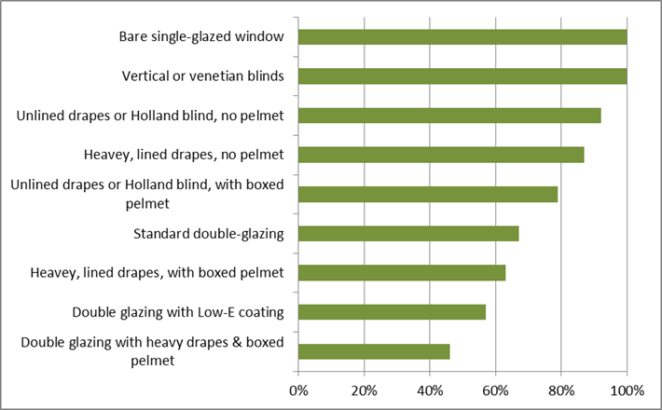
Taken from Sustainability Victoria: https://www.sustainability.vic.gov.au/research-data-and-insights/research/energy-efficiency-and-reducing-emissions/household-retrofit-trials

The key to a thermally efficient window covering is that it needs to reduce air flow across the glass and window frame as much as possible. For this reason, the most thermally efficient option is a heavy, lined curtain that extends past the sides of the window in combination with a pelmet.
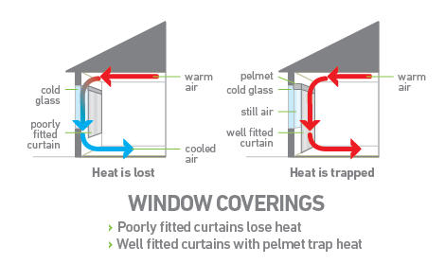
Pelmets make a big difference to all kinds of window coverings (where coverings are not fixed inside the window reveals).
- Without a pelmet, in winter, warm air that has risen to the roof touches the cold glass, drops down and out of the bottom of the window covering, pushing more warm air against the window, and you can end up with a circulating effect (also known as a convection cycle) that is continuously cooling your heated air and creating a cold draught that is often felt at your feet.
Figure 1 taken from: https://www.sustainability.vic.gov.au/energy-efficiency-and-reducing-emissions/building-or-renovating/windows-and-shading/reducing-heat-loss-through-windows
- In summer, air touches the hot glass, rises, and pulls cooler air up into the window cavity. A pelmet stops this circulating effect and thus minimizes the transfer of heat from outside to inside the house through the glass window.
You can purchase DIY invisible pelmet kits from EcoMaster or make your own:
- Attach a strip of acrylic horizontally above the window frame.
- Another DIY option http://www.diydoubleglaze.com.au/pelmets.shtml
- or google ‘DIY invisible pelmets’ for more examples.

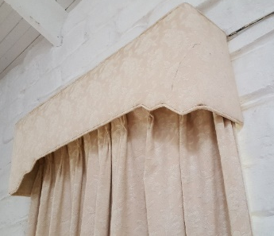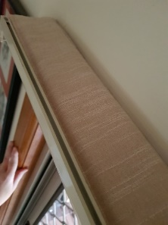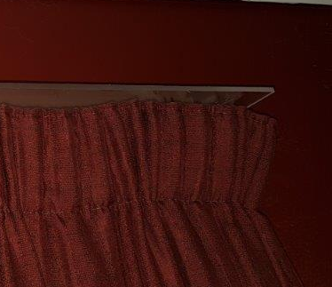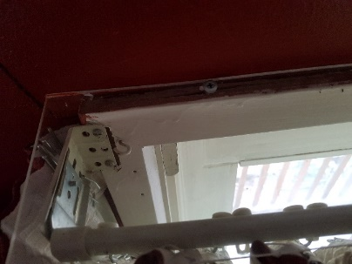
Images left to right: Traditional box pelmet, Cloth pelmet seen from above, DIY clear acrylic pelmet from front and above

Other thermally efficient options
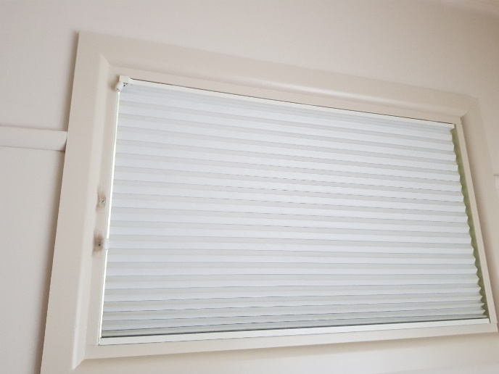
If heavy lined curtains are not an option for you, thick, lined Roman blinds (that incorporate a pelmet or are attached to the wall or frame at the top of the window) or honeycomb blinds fitted inside the frame of the windows (see image) can be good options because they both stop air flow.
Whatever you choose – ensure it is fitted in such a way that the air flow across the window is as minimal as possible. Even Holland blinds in combination with a lighter fabric curtain can be installed in a reasonably efficient way if there are only very small gaps at the sizes. These should also be fitted with a pelmet or fitted inside the window frame.
Figure 2 Honeycomb installed inside window reveal

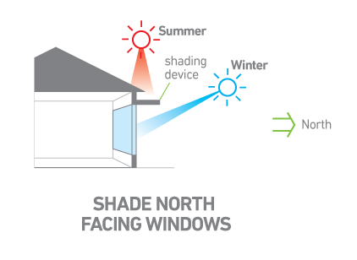
External shading
External shading is hands down the BEST way to reduce summer heat coming into your home. It performs better in summer than interior window coverings because it stops the heat before it enters your home by stopping the sun from hitting windows - for every square metre single glazing the sun directly hits, it is the equivalent of a single bar radiator being on in the room.
Image from Sustainability Victoria

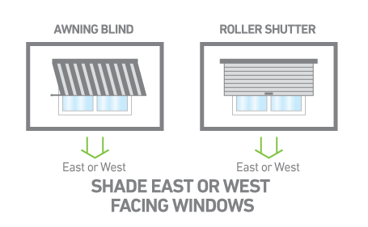
The best external shading option for north facing window is horizontal, because the sun is more likely to be high in the sky, and for east and west facing windows, vertical shade is best because the sun is at a low angle in both morning and afternoon.
When you close internal window coverings it reduces summer heat gain a bit because they stop the sunlight landing on floors, furniture etc. However, as soon as the sun rays touch your window, they will be heating up the air inside the room, especially where your window covering is thin or transparent.
Image from Sustainability Victoria

External shading includes a range of things – it is any physical barrier to stop sun touching your windows, including:
- Deciduous vines, bushes or trees that shade you in summer and drop their leaves in winter, allowing northern sunlight in to passively heat your some.
- Shade cloth or shade sails hung up over windows
- Canvas awnings
- Louvres/sliding screens
- Verandahs/pergolas
- If there are areas suffering from heat gain in summer and external blinds are not an option (e.g. windows on upper floors), low emissivity films permanently fixed to the glass can reflect significant heat with minimal loss of light. Note that these films also reduce heat gain in winter – more on this in the windows section below.
- http://www.hanitacoatings.com/energy/solarzone
- https://www.solargard.com/au/
- https://nanoshield.com.au/how-it-works/

Making the most of what you have

In winter:
keep all external doors and windows closed to retain heat in the home.
Raise external blinds and open curtains on windows that received direct sun to heat the room. Remember that for every square metre of single glazing the sun hits directly, it is the equivalent of having a single bar radiator on in the room, which can be a big bonus in winter.
Close window coverings on windows in heated zones that do not get direct sunlight to reduce the heat that is lost through the window.

In summer:
In contrast to winter, make sure all windows that experience direct sunlight are externally shaded and close the internal coverings while the sun is on the glass.
After a hot day, open as many windows as you can to the south and north to help cool the house down. The ventilation effect will be best when you open a small window on the side of the prevailing cool breeze (most often the south) and a larger window(s) on the opposite side of the house. Even though it seems counter-intuitive, this creates a better ‘suction’ effect of warm air out of the house.

Glazing
Upgrading your glazing to double or even triple glazing is a fantastic thing to do – but it’s important to consider all the other aspects to give yourself the best improvement in efficiency and comfort that also suits your use of the house and your budget. The options below are listed roughly from cheapest to most expensive (but this sometimes depends on whether you can do the installation yourself).

Bubble wrap.
Believe it or not, applying bubble wrap to your windows and (if you have them) aluminium frames really reduces heat transfer through the window. Although it might not be the classiest look, if you are renting, or if the window is out of sight such as behind a curtain in a bedroom, it can be a super cheap way of improving your comfort.

DIY removable frames fitted with film
This involves creating frames to fit into your window rebate, with a film of either clear plastic or Clear Comfort attached. When the frame is installed in the window rebate, it also gives a huge improvement to comfort by reducing heat transfer. Frames can be removed at any time, and this is a very cost effective option.
https://renew.org.au/renew-magazine/diy/diy-insulating-aluminium-windows/

Applying temporary film to window frames
There are two brands of clear window film from Clear Comfort and Duck Brand that can be applied using double-sided tape to your window frames, to create an air space between glass and the film. These give a double-glazing effect and can really improve the ability of windows to withstand heat transfer. It can take a bit of practice to work out how to apply it well, and it does not always stick well (depends on the surface). It is considered a temporary option but is very cost effective and can stay in place for many years. If you are renting, it is advisable to test the double-sided tape on one small area before applying to all windows to ensure the paint does not come off when you remove the tape.

DIY secondary glazing
Secondary glazing is when you leave the original window in place and attach a second panel or either glass or clear acrylic, leaving a gap between both panes. This creates a double-glazing effect.
This method is most suitable when your existing windows have timber frames. If you are a handy person this can be a cheap option because you are not paying for labour to cut the sheets of clear acrylic to size and attach them with timber beading to your timber frames.
If you cannot do this yourself, remember to factor in the cost of paying a handyperson or carpenter to do this work.
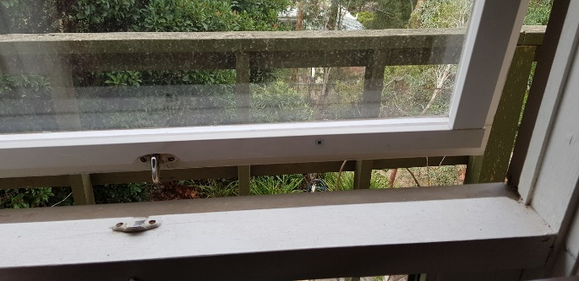
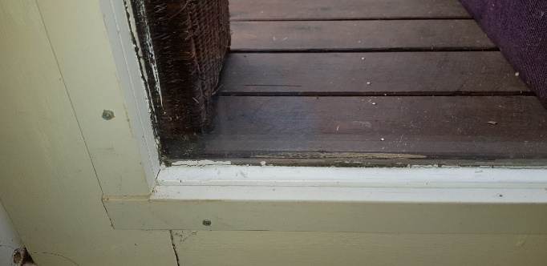
You can search online for case studies where people have added their own secondary glazing, for example: https://www.instructables.com/DIY-Double-Glazing/ and https://greenyflat.com.au/may-11-2018-diy-double-glazing/
Examples of DIY secondary glazing from authors’ home

Professional secondary glazing.
There are numerous companies who offer secondary glazing for your windows. It costs more than the DIY option but less than replacing the entire window unit (glass and frame) with a double-glazed unit.

These companies offer professional secondary glazing ONLY for timber frames windows:
ecoGlaze and Thermawood. Thermawood do a range of heritage style windows. ecoGlaze work mainly with timber frames but can work with a small range of new style aluminium frames.

Magnetite and Stop Noise offer secondary glazing for timber, steel and aluminium framed windows.
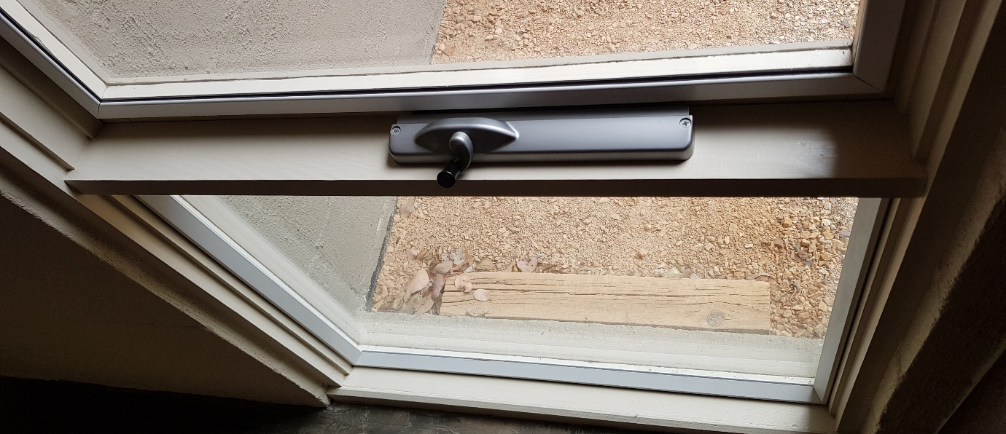
Example of professional secondary glazing added to an existing window

Adding double glazing into your existing timber frames
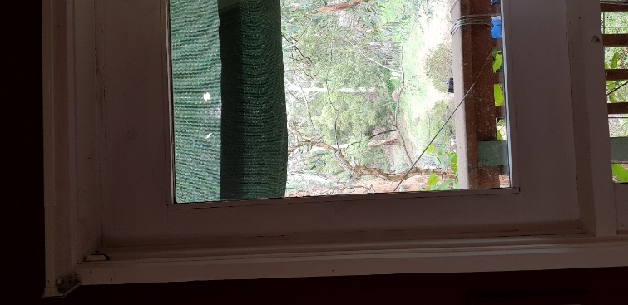
This is an excellent option if you already have timber frames in good condition. Your local glazier might be able to do this for you, or there is a Melbourne company called DIY Double Glaze who can provide you with double glazed panels (glass only) cut to size, which you can then install yourself, or hire someone to install (DIY Double Glazing can also install them for you).
Double glazing added into original timber frame
Again, this is a cheaper way to get double glazing than buying entire new windows (glass and frames).
The image to the right shows an example of where a piece of double glazing has been built into an existing timber frame.

Replacing your entire window and frame to a double-glazed unit
This is the method that many people think is their only option, whereas in fact it is the most expensive option. That does not mean it is a bad choice - if budget is no issue - then it is a wonderful choice to make. Make sure you choose either timber or UPVC frames.

Low-e coatings, tinting and films
I’ve left this option to the end because it is complex and difficult to get right without professional help. There are many films and tinting options on the market, but applied without considering all implications, they can reduce your overall comfort rather than improve it. It’s important to get the right solution based on the orientation of the window, not necessarily a blanket approach to all your windows.
Low-e window coatings can reduce heat loss through glass in winter, and reflect radiant heat in summer – however, depending on the Solar Heat Gain Coefficient (SHGC) of the coating (which varies for each product), they can also reduce passive winter heat gain which is best avoided in a cold climate such as Victoria.
Because of this, low-e coatings should only be applied where double glazing / efficient window coverings are not an option, or where you have sought specialist advice to individually match the coating to the exact windows you have, considering climate, orientation of windows and the existence of shade.
Tinting of windows is often done to reduce summer heat gain, but without thought to the fact that it will also reduce light entering the room and passive winter heat gain which is important in a cold climate such as Melbourne. I would always recommend adjustable external shading as a better option, because it can shade your windows in summer but let warmth in during winter.

Frames
Frames, just like glass, are a vehicle to transfer heat between inside and outside your home. The most thermally efficient frame is made from timber, which transfers heat really slowly. UPVC is a type of plastic. It is a good option to reduce heat transfer but is made from oil and comes in a limited range of colours. Metal frames transfer heat readily and should be avoided. Thermally broken aluminium and steel frames have a gap between the outer and inner layers and are marginally better than straight aluminium, but as you can see from the chart below, timber or UPVC are better than aluminium at reducing heat transfer regardless of whether your glass is single or double glazed.
Figure x shows that there is only a marginal benefit from replacing single glazed timber framed windows with double glazed aluminium framed windows.

Comparison of winter heat losses through windows – impact of the window frame
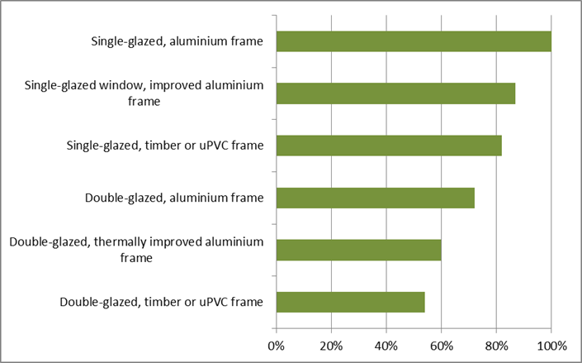
Taken from Sustainability Victoria: https://www.sustainability.vic.gov.au/research-data-and-insights/research/energy-efficiency-and-reducing-emissions/household-retrofit-trials

Getting the best match between window upgrades and your budget
Now that you have seen the various factors that impact on window thermal efficiency, consider the context of each window and make a plan that best suits each individual window, rather than thinking it is an ‘all or nothing’ approach. This will give you the best outcome in terms of comfort and budget. If you have a healthy budget, you can aim for the best choice in frames, glazing, internal coverings, and external shading. However, if your budget will not stretch that far, here are some ways you can choose the best upgrade for each window to suit your home and family.

Prioritise
Apply upgrades to the areas of the home that are used most or have the biggest impact on your comfort first, such as kitchen and living areas. You can then tackle other areas as your budget allows.

Reduce the number of windows or the size of windows in your home
Many homes have a lot more windows than they need, and with windows being such a significant source of heat loss and gain, this can have a detrimental effect on your comfort. Your aim should be to have enough windows for good natural light and natural ventilation, but not so many that they reduce your comfort. If you are renovating, you could consider removing or shrinking some windows.

Reduce the amount of operable (openable) windows in your home.
Just as some homes have more windows than they need for good sunlight and ventilation, some homes have more operable windows than are really required and replacing some of them with fixed windows can really reduce costs. The reason this can reduce your costs is because applying secondary glazing to or upgrading an operable window is more complicated that upgrading a fixed window. Poorly sealed windows will also allow heat to move in and out of your home. So, for example if you have three windows in one room that all face the same way and are all operable, you may decide that you can leave one operable and changed the other two to fixed. This will also reduce the chance of draughts from the window.

Choose an upgrade that suits each individual window
For example, often bedrooms are only occupied at night, when coverings are likely to be drawn. Considering how thermally efficient a heavy, lined curtain with pelmet is the best choice for bedrooms could be a window covering upgrade.
Kitchen and living areas are more likely to be occupied in the day, and less likely to have window coverings drawn when occupied, so if you must choose one upgrade, a glazing upgrade might be your best way to reduce heat transfer.
Areas that are not heated or cooled can be left until last for any upgrades, or you might leave them altogether if the rooms are sealed from the rest of the house.

Cost comparison of glazing upgrades
The following information is a rough guide only and you should do your own investigation before making any decisions. The price of different technologies varies widely.
According to DIYDoubleGlaze, the average cost for new double-glazed units with new frames is around $800 per square metre.
The cost for just the glazing (glass) with DIY Double Glaze is between $175/m2 (standard double glazing) to $245/m2 (double glazing with one pane of low-e coated glass), both of which are suitable if you already have good quality timber frames you can reuse. This does not include installation into your existing frames. (https://www.diydoubleglaze.com.au/cost.shtml). If you can do it yourself this could be very cost effective. If not, the installation might cost the same as or more than the glass but is still more cost effective than replacing your entire window (glass and frame).
ecoGlaze and Magnetite secondary glazing costs roughly between $375-$450 per metre square, fully installed.
DIY secondary glazing (adding a second pane of clear acrylic) is likely to cost between $100 - $200 per window, depending on who does the installation (if you do it yourself or hire someone), and how complex your windows are (e.g. if they are fixed or operable, large panes or small).
Bubble wrap, DIY film on frames and window film applied to window frames (such as Clear Comfort) are the cheapest options and you could apply these to many windows for a couple of hundred dollars.

Guides to window improvements and understanding window efficiency.
- https://renew.org.au/renew-magazine/windows/doubling-up-secondary-glazing-case-studies/
- https://renew.org.au/renew-magazine/buyers-guides/window-buyers-guide/
- https://www.sustainability.vic.gov.au/energy-efficiency-and-reducing-emissions/building-or-renovating/windows-and-shading
- https://renew.org.au/renew-magazine/buyers-guides/high-performance-curtains/
- https://www.yourhome.gov.au/passive-design/glazing
- https://www.sustainability.vic.gov.au/energy-efficiency-and-reducing-emissions/building-or-renovating/windows-and-shading/reducing-heat-loss-through-windows
- https://www.lighthouseteam.com.au/windows-101/windows-101-r-u-confused
- https://renew.org.au/renew-magazine/buyers-guides/window-buyers-guide/
- https://www.yourhome.gov.au/passive-design/glazing
- https://www.sustainability.vic.gov.au/energy-efficiency-and-reducing-emissions/building-or-renovating/windows-and-shading/reducing-heat-gain-through-windows

